# 

**EXPLORING THE IMPACT OF DIGITAL TRANSFORMATION ON CUSTOMER EXPERIENCE IN THE UK FASHION RETAIL SECTOR**

**TABLE OF CONTENTS**

Chapter 2: Literature Review 3

2.1 Introduction 3

2.2 Empirical Study 3

2.3 Theories and Models 10

2.4 Literature Gap 11

2.5 Conceptual Framework 12

2.6 Conclusion 12

References 13

# Chapter 2: Literature Review

## 2.1 Introduction

This chapter discusses the research on the adoption of digitalization to enhance customer experience in the British fashion retail industry. The areas this literature review will consider, includeing e-commerce integration, digital payment systems, CRM tools, recommender systems, virtual fitting rooms and personalized digital space. The review also considers the impact of these innovations regarding the customers and perceptions towards brands. Furthermore, it gives insights into budding problems and trends in the context of digitalization such as data evaluation as well as omnichannel integration. It explores the pre-existing knowledge and the direction of further research and acknowledges the deficiencies in the current research, such as the lack of focus on the long-term impact on consumers’ behavior and the study of SMEs’ experiences.

## 2.2 Empirical Study

**The Current State of Digitalization in the UK Fashion Retail Sector**

***Integration of E-Commerce Platforms***

According to the study by Serebryakova (2021), E-commerce platforms have been at the forefront of the increased uptake of the use of digital solutions within the fashion retail industry in the UK due to the transformation brought by the e-commerce shift in consumer shopping habits. E-commerce has revolutionized the retail industry in terms of convenience, accessibility, and product assortment, factors that physical stores fail to provide most of the time. There has been, of course, an increase in the number of consumers who prefer to shop online because it is convenient and they can buy anything from the comfort of their home, browse through different websites, compare prices, and read other people’s experiences.

In the modern world, organizations have adopted new forms of operation with the help of modern technologies, including AI and machine learning in the sphere of e-commerce. A study by Zohuri and Rahmani, (2023) revealed that these technologies allow retailers to give out recommendations regarding items based on the particular consumer’s past activities including their browsing history and past purchases. Artificial intelligence also helps in the provision of real-time customer support services through frequently used AI solutions such as chatbots and virtual assistants, who respond to the customer’s questions and issues in real-time, thus enhancing the overall experience for the customers. Moreover, big data is employed in the prediction of consumer behavior and in managing the supply of products, so important items are always available (Kyrylenko, 2024). This integration of the technology does much more than improve customer satisfaction; it propels sales and customer loyalty owing to the improved flow of the shopping experience.

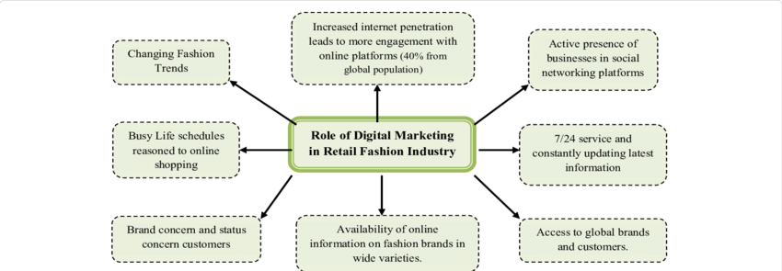

**Figure 1: Digital Transformation Marketing in Retail Sector**

(Source: Rathnayaka, 2018)

Importance of digital marketing in the retail fashion or retail industry is depicted in the figure 1 above. With the advance in internet connection, access, and technology use, fashion change and rigorous life schedules shift consumers to online shopping. Businesses have been keen to open pages in the social networking sites, hire staffs for 24-hour services and post new trends frequently (Rathnayaka, 2018). This has also triggered the growth of e-commerce and good results to customers and firms. Customers are able to get an enormous selection of international products and also information concerning fashion within the worldwide market whilst enterprises can extend the extent of consumer base as well as complementary brand image.

***Payment Systems and Customer Relationship Management (CRM) Tools***

With the advancement in e-commerce platforms, so there has been an advancement in payment platforms that offer secure, fast, and efficient payment platforms that cut across the customer experience interests. According to the study by Ward (2024), the total UK retail sales in Great Britain alone stood at £510 billion in 2023 partly due to the right distribution of consumer expenditure. Out of this total, 11 pence per pound was spent within clothing shops, rising 7% from the previous year of 2022. This increased adoption is evidenced by the significant use of contactless payment, mobile payment, and even the buy-now-pay-later services that denote that there is a tendency towards having seamless and versatile payment solutions (Ward, 2024). The inventions are formulated to minimize barriers at the point of sale and give the customer the confidence and efficiency to complete the sale, thus leading to increased satisfaction and subsequent repurchase.

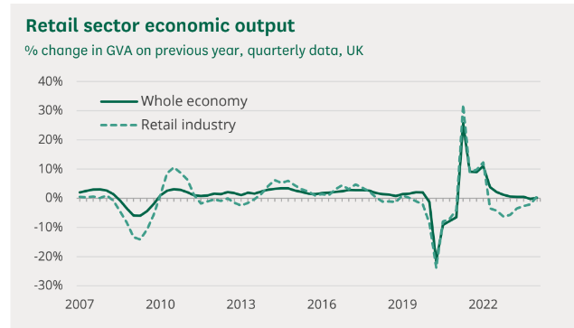

**Figure 2: Retail Sector Economic Output in the UK**

(Source: Ward, 2024)

This is evident from figure 2 above which depicts the show the oscillation of the structural contribution of the UK retail sector relative to the economy as a whole between 2007 and 2022. Similar to the general manufacturing, the retail industry was developed until 2010, the shrunk later and experienced a revival again. But due to pandamic in 2020 affected the retail sector negatively reduce the gross domestic product significantly. Although since then the sector has started improving, it is still operating far from the levels it had before the pandemic.

Another facet has to do with Customer Relationship Management (CRM) tools that have also reached a key importance in the digital retail of fashion apparels. The study by Yang and Babapour, (2023), established that through the use of CRM systems, retailers can track detailed information on customer contact, choices and purchasing behavior. CRM tools have also played an essential role in the changes that fashion retail business encounter in their digitalization. In 2023, 8 billion dollars in economic value and 4 percent of global GDP, and this needed to do it to achieve the goal of reaching 8 billion dollars in economic output in 2023 and being 4% of the world’s GDP Ward (2024). Over 9% of the total GNP of the UK receives the advantage of using CRM systems that consolidate the minutia of customer relations, choices, and past purchases. With 2. According to CRM, 7 million jobs in retail and 315,000 retail businesses as per January 2023, customers are subjected to marketing campaigns, communication, and offers that are relevant to their specific needs Ward (2024). CRM tools assist the retailers in responding to the customers’ needs proactively, communicating with the customers in a better way, and ensuring the customers stay loyal to them as they get the feeling that the retailers know them and are there to attend to their needs (Alexander, 2024). It is a major advantage in the highly saturated fashion retail industry, as customer loyalty becomes a major issue to businesses. By these digital activities the UK fashion retail sector adapts to the constant changes of the marketplace while simultaneously improving the total customer satisfaction and the bonding between brands and customers (Lorenzo-Romero *et al*., 2023).

**The Impact of Digitalization on Customer Satisfaction in Fashion Retail**

***Role of Recommendation Systems***

Ogunjimi *et al*., (2021) also argue that recommendation systems are a significant innovation in digital retail, influencing customer satisfaction by enhancing the shopping experience. These systems analyze customer data to suggest products that align with their preferences, leading to more personalized shopping experiences. In the retail sector, recommendation systems have proven particularly effective, as they help customers discover new products that match their style, increasing the likelihood of purchase and overall satisfaction. According to Ogunjimi *et al.,* (2021), recommendation systems highly depend on the data gathered by those platforms, as well as the algorithms that process the information. Research also indicates that customers are willing to continue using companies that make appropriate recommendations because suggestions minimize the amount of time and energy one has to spend looking for the right products. However, weak system implementations undermine these positive outcomes and result in frustrations from the users (Ogunjimi *et al.,* 2021).

***Influence of Virtual Fitting Rooms on Consumer Perceptions***

According to Lee, (2021), that has a direct bearing on the satisfaction index of customers in fashion retailing is what has been referred to as Virtual Fitting Rooms or VFRs. Its use of VFRs involves customers being able, with the help of augmented reality (AR), to ‘wear’ some of the clothes virtually, and see how such articles would fit them without the need to put the garments on. It can be regarded as the solution to a major problem of internet shopping: clothes fitting and appearance, which in its turn, contributes to the decrease of the rates of returning garments and increased satisfaction among customers.

A recent study by Karlsson and Skarin (2023) found that the reactions of consumers toward the adoption of VFRs has also received positive responses that are attributed to the usual benefits of convenience and accuracy. Their study showed that VFRs do not only enhance customer satisfaction but also enhance purchase confidence since several customers are more willing to purchase items they have ‘tasted’ virtually. Nevertheless, the efficiency of VFRs is highly influenced by the realism of the informing technology and the design of the user interface. Karlsson and Skarin (2023) argue that when VFRs are not well done, they create a negative image that enhances the need to invest in good digital tools.

**Customer Perceptions of Personalized Digital Environments**

***Shaping Customer Impressions Through Personalization***

In a study by Yeo *et al*. (2022), the digitalization of the fashion retail sector has prompted the adoption of the concept of personalization, whereby consumers’ unique experiences are designed by using data. Consumers are discovering that retailers are starting to use more and more complex equations to manage the data that they gather about their consumers’ browsing and buying history as well as demographic details. It has been suggested by Yeo *et al.* (2022) that this level of personalization greatly increases the satisfaction of customers due to the targeted shopping experience. In situations where customers are offered the products that they prefer and need, they feel valued and understood which increases the level of the bond customers have with the brand.

Ying *et al*. (2021), argue that the use of personalization depends on the effective ~~of~~ balancing between the relevancy and the privacy of information being used. Although the customers value the ease and customization, they also are getting more cautious about the collection, storage, and usage of their information. Customers need to understand how their data is collected and used; retailers have to express their policy on data usage and give customers a chance to manage possession of their data. Transparency also works in enhancing the trust levels that are critical in sustaining the brand image and customer loyalty (Ying *et al*., 2021). Where data misappropriation scandals and lack of user consent have become the general norm, the long-term business relationships that the current retailers are likely to build are with those consumers who fully comprehend and trust the data usage by the retailers.

***Influence on Brand Loyalty***

A study by Rane *et al*. (2023), found that a Personalized web environments are not just the means of providing an instant customer satisfaction but also one of the key tools to establish long-term relationships with brands. Different studies have revealed that if customers are offered high personalization, then they are most likely to develop high level of branded emotional attachment and are more likely to return to make repeat purchases in the future. Personalization emerges as a strategic way of forging long-term consumer bonds in fashion retail, where identity and experience are intertwined (Rane *et al*., 2023). Through presenting customers with exclusivity, which is scarce in the market today, retailers increase their chances of making the customer patronize their brand to the exclusion of others.

The process of personalization can be effective, taking into account certain nuances. Indrabrata and Balqiah, (2020) found that negative consequences of over-personalization include over-exposure in which the customer is exposed to too many targeted advertisements, which may cause the customer to become irritated. They may get annoyed or feel as if the brand is pressuring them, straining their relationship with the brand and making consumers avoid them. Study by Indrabrata and Balqiah, (2020), major retailers must develop customer insights and big data to carefully balance their approach to personalization so that instead of overwhelming customers with offers, it becomes engaging to them. In doing so, they can improve the Customer Experience, retain the existing customers, and thus build long-term success in the fashion retail industry.

**Challenges and Opportunities Arising from Digitalization**

***Challenges***

According to Casciani *et al*., (2022), although digitalization seems to bring about many opportunities for fashion retailers, some problems need to be solved to make full use of this opportunity. The first critical issue can be considered the lack of omnichannel integration concerning digital tools in online and offline stores. To have a situation where the customer journey essentially flows from digital to physical contact through the processes of purchase, there is a need to invest significantly in technology and the physical self (Casciani *et al.*, 2022). This suggests that there is a need for sophisticated systems in implementing omnichannel strategies to ensure that there is uniformity in inventory, customer experience, and product availability across various channels of contact. It is not only expensive but also challenging to attain this integration because of the need to understand the customers based on the mode of communication used to offer them a seamless experience (Thrassou *et al.,* 2021).

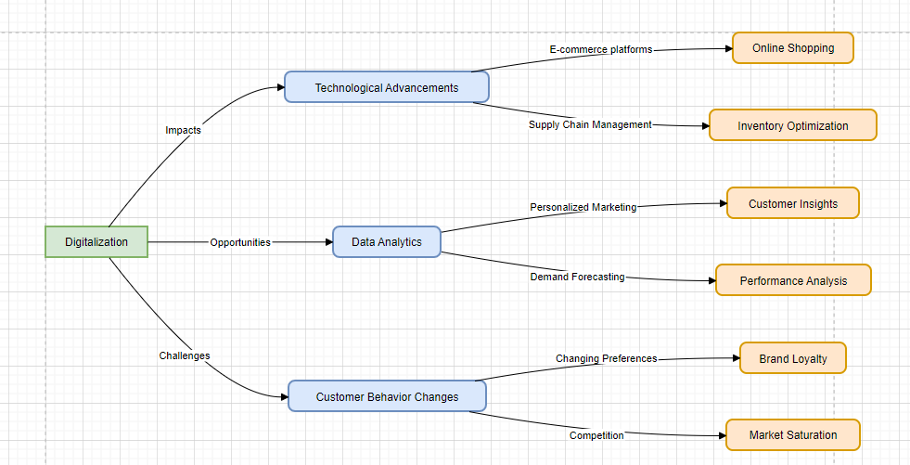

**Figure 3: Impacts, Challenges and Opportunities arising from Digitalization**

(Source: Self-created)

The diagram outlines the impacts of technological advancements on e-commerce, highlighting areas like online shopping, supply chain management, personalized marketing, and customer insights. It emphasizes opportunities such as data analytics and demand forecasting, while also addressing challenges like shifting customer preferences, brand loyalty, market competition, and saturation in the digital landscape.

The last major issue is the problem of handling and safeguarding clients’ information. According to Stortoni (2020), the prominence of big data in decision-making, targeting, and CRM is today quite hard for retail businesses to manage under GDPR rules in Europe and similar laws in other parts of the world. Compliance with these regulations should be stressed as failure entails incurring penalties and losing the confidence of its customers. It is important because everybody knows what may happen if customer data is leaked or misused – a brand image can be seriously damaged and customer trust is gone. Retailers have to adopt protective measures within security and data sharing to address these risks for the protection of customer information.

***Opportunities***

According to recent study by Sagar (2024), digitalization opens a plethora of prospects for improving the shopping experience for fashion retailers and increasing the scale of their business. The greatest opportunity is that there is the potential to capture vast amounts of customer data about customers for use in selling products. This data proves to be very useful as it gives insights on customers’ preferences, their buying behavior, and the trends in the market which make it easier for retailers to market their products or services more strategically (Penn LPS, 2022). Thus, retailers could provide personalized marketing promotions, effectively control their stock, and design products that would better fit the customers’ needs and wants, which would result in increased sales and customer satisfaction.

According to Dagnaw (2020), Computer technologies including artificial intelligence (AI) and machine learning are also promising in enabling robotic process automation in areas like inventory tracking, demand forecasting or customer support. Automation helps minimize costs and time, and at the same time, leads to resource redeployment, which can be very useful for radical decisions, for example, in creating new products, engaging with customers. In addition, it is equally true that the digitalization of banking presents new opportunities in the interaction with the customers. Facebook, twitter, applications/ games, and online community groups are perfect for retailers to engage consumers in real time, and get consumers to become part of the community and brand (Dagnaw, 2020). By these platforms, retailers can offer a more engaging experience to their clients in line with today’s modern consumers. For instance, brands leverage this platform to present new products, have live sales or respond to their audiences with more relatable content and offers. Consequently, digitalization has been challenging regarding integrating and handling technology in fashion retail outlets but beneficial in aspects such as customer experience, efficiency, and growth (Dagnaw, 2020). With regards to the challenges and possibilities mentioned above, the retailers can find themselves well-placed in a constantly advancing digital game.

## 

## 2.3 Theories and Models

As it relates to the occurrence of digitalization in the context to the fashion retail sector certain theories and models can be useful in formulating adoption of digital technologies. One of such models is the Technology Acceptance Model (TAM) which portrays how a user adopts a particular technology. Natasia *et al*., (2022) argued that TAM, two primary factors influence this acceptance concretely presented two perceived factors: perceived usefulness and perceived ease of use. When it comes to fashion retail, both the customer and the retailer can relate to this in the use of e-commerce platforms, and CRM among other elements. There is a need to make sure that these technologies will improve the business for retailers and be easy to use so that will be adopted by many firms.

Another theory that connects with this area is Rogers’ Diffusion of Innovations Theory which explain when, why, and at what rate innovation effect cultures. A study by Hains and Hains, (2020) founded that this theory identifies several adopter categories: that is, innovators, early adopters, early majority, late majority, and laggards. In fashion retail context, Diffusion of Innovations Theory assists in explaining how consumer segments adopt digital shopping experiences differently (Hains and Hains, 2020.). For example, innovators and early adopters are likely to try and utilize new technologies like digital fitting rooms or conversational AI for shopping, whereas laggards are unlikely to do so without prior confirmation of the new technology’s efficacy. It has been well documented in the Resource-Based View (RBV) theory, developed by Wernerfelt, that all resources and capabilities of a firm determine competitive advantage (Sugiarno and Novita, 2022). It is the vital tools that the fashion retailer needs to impact as a significant source of competitive advantage in a competitive market (Lubis, 2022). These resources, therefore, when optimally deployed, bring about customer improvement, operations efficiency, and promptness in responding to dynamic markets, so as to maintain competitive advantage. These theories and models explain the key forces that are shaping the pattern of digital transformation in the fashion retail industry to support decision making to business organisations in fashion retail that seeks to compete effectively in the digital economy.

## 2.4 Literature Gap

Even though the literature is dotted with research on digitalization in fashion retail business, little is known about the impact of digitalization on long term consumer behaviour and brand loyalty. Researchers have mostly explored the direct effects of e-commerce integration, individualized communications and CRM initiatives, with attention paid almost exclusively to the uptake of technologies and first-order consumer reactions (Guha, 2021). However, there is still scarce research that analyses how these forms of digital commitments affect consumer loyalty, especially within a dynamic technological environment (Chen *et al.*, 2021). Additionally, the bias is that studies mostly focus more on big, established chains and little is still known about digitalization prospects for Small and Medium-sized Enterprises (SMEs) in fashion (Kang and Choi, 2024). This is a failure to study SMEs in isolation of the fact that such firms might face different limitations and might be utilizing different strategies to survive in the new digital economy. The advantages of personalization are clear and one can and should look for more papers exploring the tensions between personalization and consumers’ privacy. Knowledge of how consumers think about data usage and privacy in personalized digital contexts is important for creating approaches that sustain trust as well as augment the value of customer experiences. Here, filling these gaps will enhance the understanding of how digitalization affects the fashion retail industry.

## 

## 2.5 Conceptual Framework

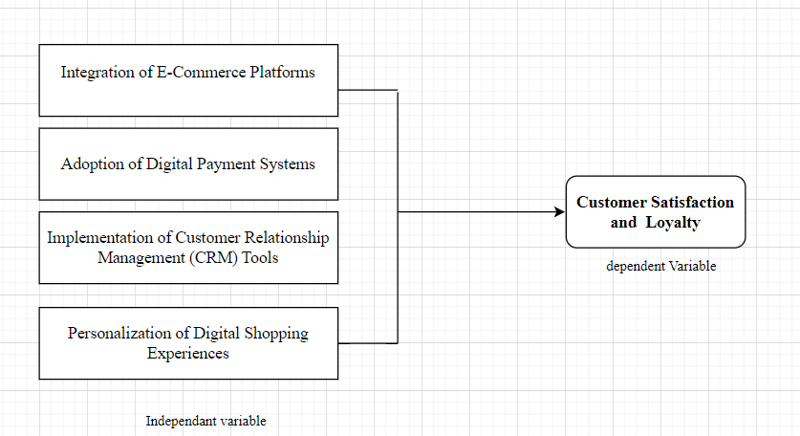

**Figure 4: Conceptual Framework**

(Source: self-created)

The diagram illustrates the relationship between independent variables (E-commerce platform integration, digital payment adoption, CRM tools, and personalized shopping experiences) and the dependent variable (customer satisfaction and loyalty), emphasizing how these digital strategies influence customer engagement and retention.

## 

## 2.6 Conclusion

In this chapter, the review has analyzed the extent of digital disruption and its effects on customer experience in the UK fashion retail industry, where various gains, including e-commerce retailing, digital payment systems, CRM solutions, and personalized surroundings, have been outlined. At the same time, it highlights how these advancements improve the customer experience and brand equity and sheds light on risks, such as data and multichannel and multiscreen integration. Gaps are also discussed, especially regarding the consequences of digitalization in a long period and the particularities related to SMEs' needs. Closing these gaps will be vital for the retailers who will seek to harness digital technologies optimally and sustainably to enhance its interactions with the customers and competitively.

# 

# References

Alexander, T., (2024). Proactive Customer Support: Re-Architecting a Customer Support/Relationship Management Software System Leveraging Predictive Analysis/AI and Machine Learning. Engineering: Open Access, 2(1), pp.39-50. <https://www.opastpublishers.com/open-access-articles/proactive-customer-support-rearchitecting-a-customer-supportrelationship-management-software-system-leveraging-predictiv.pdf>

Andreoni, A., Barnes, J., Black, A. and Sturgeon, T., (2021). Digitalization, industrialization, and skills development: Opportunities and challenges for middle-income countries. <https://library.oapen.org/bitstream/handle/20.500.12657/50510/1/9780192894311.pdf#page=290>

Casciani, D., Chkanikova, O., & Pal, R. (2022). Exploring the nature of digital transformation in the fashion industry: opportunities for supply chains, business models, and sustainability-oriented innovations. Sustainability: Science, Practice and Policy, 18(1), 773-795. [https://www.tandfonline.com/doi/pdf/10.1080/15487733.2022.2125640](%20https://www.tandfonline.com/doi/pdf/10.1080/15487733.2022.2125640)

Chen, Y., Mandler, T. and Meyer-Waarden, L., (2021). Three decades of research on loyalty programs: A literature review and future research agenda. Journal of Business Research, 124, pp.179-197. [https://fardapaper.ir/mohavaha/uploads/2021/05/Fardapaper-Three-decades-of-research-on-loyalty-programs-A-literature-review-and-future-research-agenda.pdf](%20https://fardapaper.ir/mohavaha/uploads/2021/05/Fardapaper-Three-decades-of-research-on-loyalty-programs-A-literature-review-and-future-research-agenda.pdf)

Dagnaw, G. (2020). Artificial intelligence towards future industrial opportunities and challenges. <https://digitalcommons.kennesaw.edu/cgi/viewcontent.cgi?article=1027&context=acist>

Guha, S., (2021). Absorbing and adapting to new technologies: Social CRM implementation in SMEs. <https://research-repository.uwa.edu.au/files/167381334/THESIS_DOCTOR_OF_PHILOSOPHY_GUHA_Sushmita_2022.pdf>

Hains, B.J. and Hains, K.D., (2020). Community reaction towards social innovation: A discussion of Rogers’ Diffusion of Innovations theory in consideration of community emotional response. Journal of International Agricultural and Extension Education, 27(1), pp.34-46. <https://newprairiepress.org/cgi/viewcontent.cgi?article=1398&context=jiaee>

Indrabrata, A., & Balqiah, T. E. (2020, December). Effect of Perceived Personalization and Self Expressive Brand towards Perceived Quality and Brand Loyalty of Local Footwear Brands on Instagram. In The International Conference on Business and Management Research (ICBMR 2020) (pp. 62-70). Atlantis Press. [https://www.atlantis-press.com/article/125949935.pdf](%20https://www.atlantis-press.com/article/125949935.pdf)

Kang, J.Y.M. & Choi, D., (2024). Artificial intelligence-powered digital solutions in the fashion industry: a mixed-methods study on AI-based customer services. International Journal of Fashion Design, Technology and Education, 17(2), pp.162-176. <https://www.researchgate.net/profile/Ju-Young-Kang-2/publication/374322463_Artificial_intelligence-powered_digital_solutions_in_the_fashion_industry_a_mixed-methods_study_on_AI-based_customer_services/links/66677a4fa54c5f0b945d7e44/Artificial-intelligence-powered-digital-solutions-in-the-fashion-industry-a-mixed-methods-study-on-AI-based-customer-services.pdf>

Karlsson, L. & Skarin, E., (2023). To Adopt or Not to Adopt, That is the Question: An Analysis of Drivers and Barriers for Adoption of Virtual Fitting Rooms in the Swedish online fashion retail market. [https://gupea.ub.gu.se/bitstream/handle/2077/78587/V23%20FEK3S5%20Arkivex%20CS%2022%2023%205.pdf?sequence=1](%20https://gupea.ub.gu.se/bitstream/handle/2077/78587/V23%20FEK3S5%20Arkivex%20CS%2022%2023%205.pdf?sequence=1)

Kyrylenko, Y., (2024). Chatbots and virtual assistants vs. human agents in IT customer support. [https://lauda.ulapland.fi/bitstream/handle/10024/66071/Kyrylenko_Yevheniia.pdf?sequence=1&isAllowed=y](%20https://lauda.ulapland.fi/bitstream/handle/10024/66071/Kyrylenko_Yevheniia.pdf?sequence=1&isAllowed=y)

Lee, H. (2021). Fashion consumers’ perception and adoption of virtual fitting rooms (VFRs): A perspective of regulatory focus and shopping involvement. North Carolina State University. [https://repository.lib.ncsu.edu/bitstream/handle/1840.20/38519/etd.pdf?sequence=1](%20https://repository.lib.ncsu.edu/bitstream/handle/1840.20/38519/etd.pdf?sequence=1)

Lorenzo-Romero, C., Alarcón-del-Amo, M.D.C. and Frasquet-Deltoro, M., (2023). A latent approach in the fashion retailing context: segmenting co-creator users. Fashion and Textiles, 10(1), p.11. [https://link.springer.com/content/pdf/10.1186/s40691-022-00323-7.pdf](%20https://link.springer.com/content/pdf/10.1186/s40691-022-00323-7.pdf)

Lubis, N.W., (2022). Resource based view (RBV) in improving company strategic capacity. Research Horizon, 2(6), pp.587-596. <https://doi.org/10.54518/rh.2.6.2022.587-596>

Natasia, S.R., Wiranti, Y.T. & Parastika, A., (2022). Acceptance analysis of NUADU as e-learning platform using the Technology Acceptance Model (TAM) approach. Procedia Computer Science, 197, pp.512-520. [https://www.sciencedirect.com/science/article/pii/S1877050921023929/pdf?md5=cac6c50b5769fee3890857460442d852&pid=1-s2.0-S1877050921023929-main.pdf](%20https://www.sciencedirect.com/science/article/pii/S1877050921023929/pdf?md5=cac6c50b5769fee3890857460442d852&pid=1-s2.0-S1877050921023929-main.pdf)

Ogunjimi, A., Rahman, M., Islam, N., & Hasan, R. (2021). Smart mirror fashion technology for the retail chain transformation. Technological Forecasting and Social Change, 173, 121118. <https://mural.maynoothuniversity.ie/18327/1/RajibulHasanSmart2021.pdf>

Penn LPS (2022). 5 key reasons why data analytics is important to business | Penn LPS Online. [online] lpsonline.sas.upenn.edu. <https://lpsonline.sas.upenn.edu/features/5-key-reasons-why-data-analytics-important-business>.

Rane, N.L., Achari, A. & Choudhary, S.P., (2023). Enhancing customer loyalty through quality of service: Effective strategies to improve customer satisfaction, experience, relationship, and engagement. International Research Journal of Modernization in Engineering Technology and Science, 5(5), pp.427-452 [https://www.researchgate.net/profile/Nitin-Rane-2/publication/370561455_Enhancing_customer_loyalty_through_quality_of_service_Effective_strategies_to_improve_customer_satisfaction_experience_relationship_and_engagement/links/645612ad97449a0e1a7f308a/Enhancing-customer-loyalty-through-quality-of-service-Effective-strategies-to-improve-customer-satisfaction-experience-relationship-and-engagement.pdf](%20https://www.researchgate.net/profile/Nitin-Rane-2/publication/370561455_Enhancing_customer_loyalty_through_quality_of_service_Effective_strategies_to_improve_customer_satisfaction_experience_relationship_and_engagement/links/645612ad97449a0e1a7f308a/Enhancing-customer-loyalty-through-quality-of-service-Effective-strategies-to-improve-customer-satisfaction-experience-relationship-and-engagement.pdf)

Rathnayaka, U. (2018). Role of digital marketing in retail fashion industry: A synthesis of the theory and the practice. Journal of Accounting & Marketing, 7(02). <https://www.researchgate.net/profile/Udayangani-Rathnayaka/publication/325987704_Role_of_Digital_Marketing_in_Retail_Fashion_Industry_A_Synthesis_of_the_Theory_and_the_Practice/links/5b31e8cf4585150d23d46269/Role-of-Digital-Marketing-in-Retail-Fashion-Industry-A-Synthesis-of-the-Theory-and-the-Practice.pdf>

Sagar, S., (2024). The Impact Of Digital Transformation On Retail Management And Consumer Behavior. IOSR Journal of Business and Management (IOSR-JBM) e-ISSN, pp.06-14. [https://www.researchgate.net/profile/Sahil-Sagar-5/publication/377189041_The_Impact_Of_Digital_Transformation_On_Retail_Management_And_Consumer_Behavior/links/65993f0e0bb2c7472b364119/The-Impact-Of-Digital-Transformation-On-Retail-Management-And-Consumer-Behavior.pdf](%20https://www.researchgate.net/profile/Sahil-Sagar-5/publication/377189041_The_Impact_Of_Digital_Transformation_On_Retail_Management_And_Consumer_Behavior/links/65993f0e0bb2c7472b364119/The-Impact-Of-Digital-Transformation-On-Retail-Management-And-Consumer-Behavior.pdf)

Serebryakova, A. (2021). Local shopping platform as a means of overcoming the challenges of digital transformation: User requirements assessment (Doctoral dissertation, Technische Hochschule Ingolstadt). <https://opus4.kobv.de/opus4-haw/files/3291/I000954551Thesis.pdf>

Stortoni, F., 2020. The Exploitation of Big Data Technologies in Chinese Retail: Towards the Creation of a Regulatory Framework for Privacy Protection. <http://dspace.unive.it/bitstream/handle/10579/18436/856935-1258606.pdf?sequence=2>

Sugiarno, Y. and Novita, D., (2022), August. Resources-Based View (RBV) as A Strategy of Company Competitive Advantage: A Literature Review. In International Conference On Economics Business Management And Accounting (ICOEMA) (Vol. 1, pp. 656-666). [https://conference.untag-sby.ac.id/index.php/icoema/article/download/2196/1243](%20https://conference.untag-sby.ac.id/index.php/icoema/article/download/2196/1243)

Thrassou, A., Uzunboylu, N., Vrontis, D. and Christofi, M., (2020). Digitalization of SMEs: A review of opportunities and challenges. The Changing Role of SMEs in Global Business: Volume II: Contextual Evolution Across Markets, Disciplines and Sectors, pp.179-200. [https://link.springer.com/chapter/10.1007/978-3-030-45835-5_9](%20https://link.springer.com/chapter/10.1007/978-3-030-45835-5_9)

Ward, M. (2024, July 21). Retail Sector in the UK. <https://researchbriefings.files.parliament.uk/documents/SN06186/SN06186.pdf>

Yang, Z. and Babapour, H., (2023). Critical variables for assessing the effectiveness of electronic customer relationship management systems in online shopping. Kybernetes, 52(9), pp.3044-3063.  [https://www.academia.edu/download/95709439/ecrm_in_online_shopping.pdf](%20https://www.academia.edu/download/95709439/ecrm_in_online_shopping.pdf)

Yeo, S. F., Tan, C. L., Kumar, A., Tan, K. H., & Wong, J. K. (2022). Investigating the impact of AI-powered technologies on Instagrammers’ purchase decisions in digitalization era–A study of the fashion and apparel industry. Technological Forecasting and Social Change, 177, 121551.. <https://www.sciencedirect.com/science/article/am/pii/S004016252200083X>

Ying, S., Sindakis, S., Aggarwal, S., Chen, C. and Su, J., (2021). Managing big data in the retail industry of Singapore: Examining the impact on customer satisfaction and organizational performance. European Management Journal, 39(3), pp.390-400. <https://e-tarjome.com/storage/btn_uploaded/2020-09-26/1601107497_11342-etarjome%20English.pdf>

Zohuri, B. and Rahmani, F.M., (2023). Artificial intelligence driven resiliency with machine learning and deep learning components. Japan Journal of Research, 1(1). <https://journals.sciencexcel.com/index.php/jjr/article/download/8/5>